Node JS

1. Before using the node.js make sure that you have installed it in the system, And if not installed it, than install it first from the its official website
2. Before starting write the following commands in the terminal, before starting further

**node --version**

**npm –version**

1. The npm stands for the **node package manager** and it helps us to install the packages
2. And to make an project to run we have to first write the **npm init** to initialize the project first and it will ask the questions to make an package.json file in the project folder, the questions which are asked are as follow:

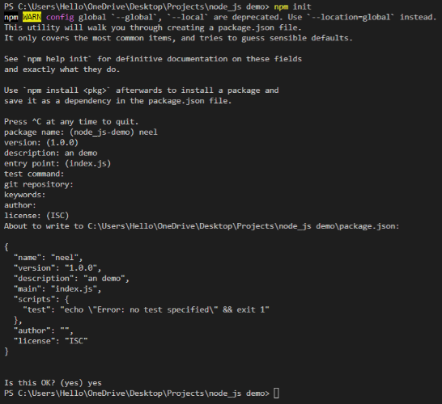

1. And we can also install the various packages in the node by writing the **npm install <package name>** commad, For example for installing the express.js which is an famous web framework we will write **npm install express –save**
2. By installing an package in the project folder, an folder named the node_modules is made
3. And when we give our applications to an person, We do not give the node_modules named folder to him, And one can easily make that node modules folder, And we also do not push this node_modules folder into the git as this folder is very heavy , And the node_modules folder can be get by simply writing the **npm install or npm i**
4. We can run the any .js file in the system by writing the node **<file-name>.js** or if you are in the vs code, than we can also directly run it by clicking on the run button
5. Node.js works on the **asynchronous non-blocking I/O Model** and due to it than node.js can only make one thread run at a time, And if one thread blocks the process than it can prioritise the another work first, Hence the statement written first can also be executed after the second statement, And this can also be made the line wise by writing or using the await function
6. The apache server runs on the system of the multiple threads at a time
7. We can also install the nodemon package in the project, by the help of which we can see the change that we made in any file, And it is also very useful while we are working with the http servers, It can be installed by simply writing the **npm install nodemon**

**🡪By saving the file, nodemon automatically restarts the server**

1. And we can run the nodemon by simply writing the **nodemon <file-name>,** for doing it for whole website we can start it for index page like **nodemon index.js**
2. We can also install an dependencies as the dev dependencies by help of **--save-dev**, Example **npm install --save-dev nodemon**, And by installing an dependencies as the dev dependencies we can only use them at the time of the development, And it will be not used after the production is completed
3. We can also uninstall an package by writing the **npm uninstall<package-name>,** Example **npm uninstall nodemon**
4. We can import any thing like the object from the one file to the other by the help of the require function

🡪The place from where we want to export there we have to write

**export function simple(){**

**console.log(“Simple is complex”);**

**}**

🡪And the place where you want to import we have to write

import simple from “./modulesecond”

🡪If the error comes than in package.js write the following red boxed thing in it :

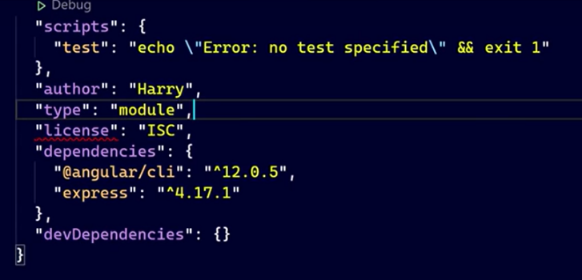

1. If we are importing the man-made module than we have to write like “./Second” and if we are importing the inbuilt module than we can directly download it by the help of its name “Seconnd”
2. By the help of the nodejs we can also read and write the data from the file by the help of the fs module and fs.writeFile, fs.readFile
3. We can also make an function to be called after the one is completed by the help of the following way

fs.writeFile(‘file2.txt’, “This is a data”, ()=>{

console.log(“Written to the file”);

})

🡪And in this method the console.log will wait until the fs.writeFile is been implemented

1. Node.js works on the event driven architecture, So that you can make the event to fire from anywhere and the once event is fired you can listen it and perform some actions
2. We can also make our own event handler by the help of the following way :

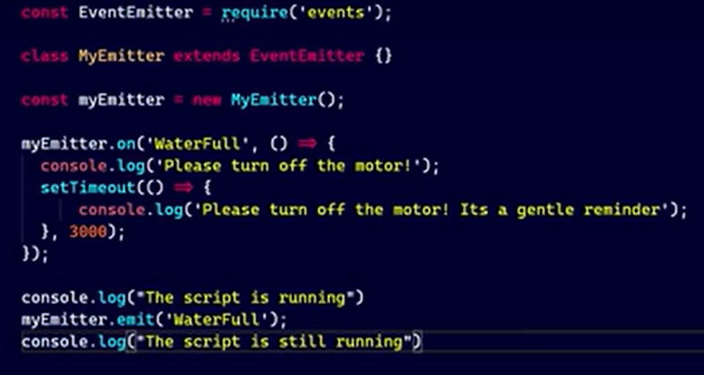

🡪In this code the following code will be run when the waterfall keyword is used and the initiation of the event can be done by the help of the .on method and than by the help of the arrow function can define what to do when called

🡪And the function can be called by the help of the .emit method

1. We can also make an server in the node js by the help of the following code but it is not recommended to use the node js directly to manage the server instead of it you can use the express.js which can make the process very easy, Both the ways of doing it is as followed :

🡺In node.js

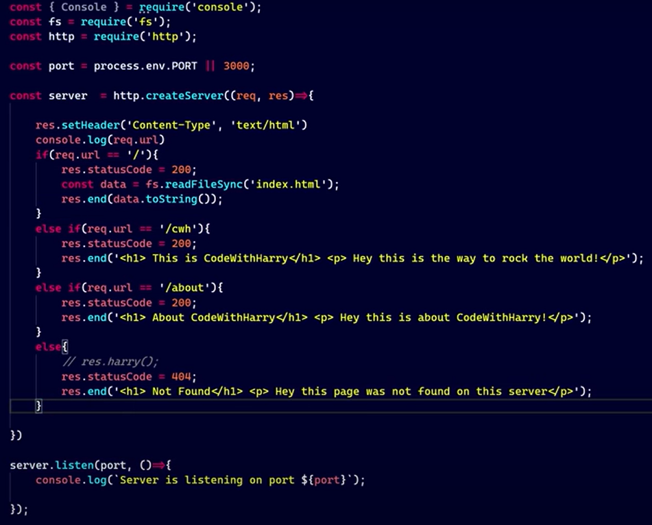

🡺In express.js

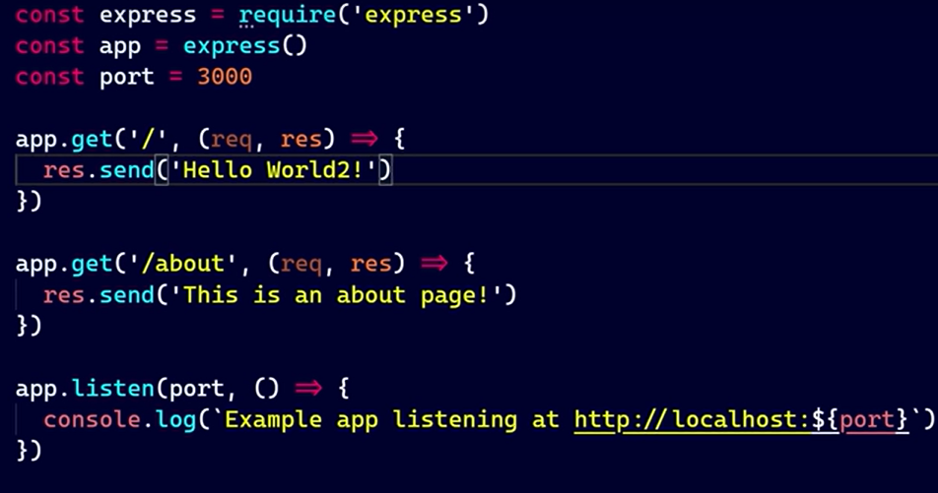

🡪For more information about the express.js go to the express.js documentation that I have maded